CAMBRIDGE MUSEUM
OF
TECHNOLOGY

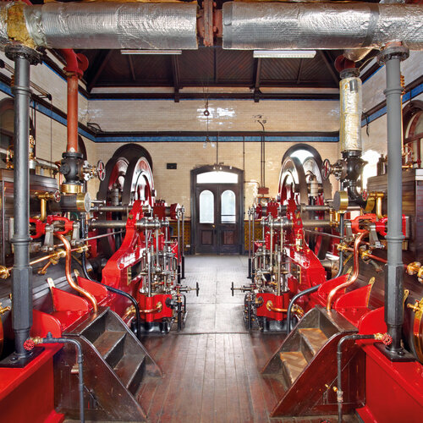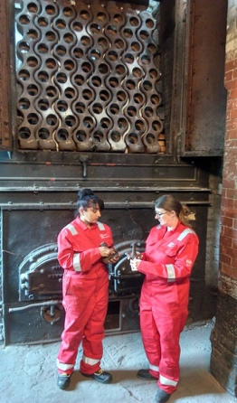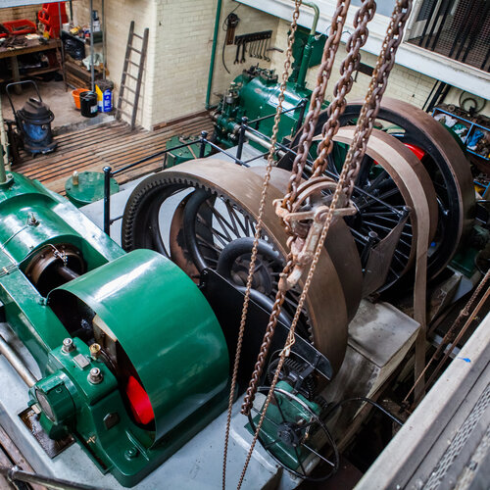
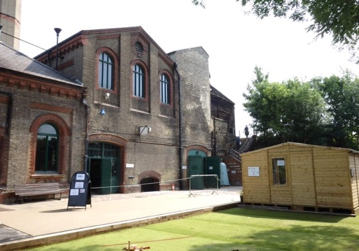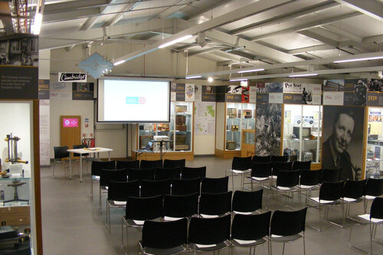 2023

Candidate Pack – Chair of Trustees

Contents:

Introduction from the Chairman 3.

Cambridge Museum of Technology 4.

Chair of Trustees Role Description 7.

How to Apply 8.

Expectations of Trustees 10.

Introduction

Thank you for your interest in becoming chair of the board of trustees of Cambridge Museum of Technology. This information pack provides an introduction to the museum, what it is doing and our forward plans.

Our museum is independent, accredited by the Arts Council, and based in the old Victorian sewage pumping station on Riverside, Cambridge. The site is owned by the museum. The main building is a scheduled monument on Historic England’s At-risk register.

Recent development funding has come from the National Lottery Heritage Fund (NLHF), Historic England, Pye Foundation, Garfield Weston, Foyle Foundation, FCC Communities Foundation, public appeals and donations.

In addition to preservation of its collections and the historic buildings, we see the museum as a community, family and educational facility in eastern Cambridge. We have also always been known for live demonstration of technology such as boilers, steam, gas and electric pumping engines and other machinery associated with Cambridge.

Our main challenge recently has been emerging from Covid, developing revised business plans to deal sustainably with the impact of that, then to move forward again with the huge variety of family, education and community activities we have developed, discover and develop new ones, and increase our capacity and resources at all levels: trustees, volunteers, staff, and site improvements. This in turn will require a further fundraising drive.

The board of trustees meets six times per year Recently these have been online using Teams. Individual trustees are also involved in chairing committees (e.g. management committee, technical committee, collections committee and finance and fundraising committee) and driving particular projects.

We currently have nine trustees of the eleven permitted by the constitution. Two will need to step down at the end of 2023 including the current chair.

If after reading the attached information you feel you would like to apply to become chair of trustees then please contact John Little at john.little@museumoftechnology.com for an informal discussion or send your CV and a covering letter.

John Little
Chair of the Board of Trustees

Cambridge Museum of Technology

Who Are We?

Cambridge Museum of Technology is an independent, accredited museum based in the old Victorian Pumping Station on Riverside to the east of Cambridge city centre. The organisation is a Charitable Incorporated Organisation (CIO) which is a form of limited liability constitution designed to meet the needs of charitable organisations.

Our Team

Currently we have a Front of House Manager and Office Administrator. Previously we also had an education officer and assistant curator, but we cut costs during the Covid pandemic in order to remain sustainable. We are now bidding for grants to appoint an Enterprise Manager, an Education/Community Officer and a Collections Officer. The bulk of the work on site has always been done by a large team of volunteers and that is still the case.

Trustees have been active in fundraising and finance, site maintenance, technical work, education and assisting with museum accreditation, as well as helping out as duty managers and front of house roles. Their core long term role is in governance, strategy and forward planning, responsibility for the scheduled monument, reviewing staff needs and performance, and approving policies.

Trustee roles, including the chair, are not remunerated. The role is subject to the constitution and charity law.

Our Vision

We are a community, educational, and event hub based in a unique heritage site, serving the local community and visitors from everywhere.

Our Mission
Our Mission is:

‘To preserve and demonstrate the industrial and technological heritage of Cambridge for the inspiration, enjoyment and education of all.’

We will achieve this mission by:
- Collecting and preserving objects and stories relating to the industrial heritage of Cambridge
- Preserving the Museum’s historic industrial site, building and associated machinery
- Displaying, interpreting and demonstrating the collections, the historic site, building and machinery plus associated stories for everyone to enjoy, explore and learn from.
- Operating the collections where practicable
- Overcoming as many physical, intellectual and financial barriers as possible to provide the widest possible access to all of our buildings, collections and facilities.
- Marketing the Museum to appeal to a broad range of target audiences.
- Developing the Museum as a friendly and high quality centre and resource for the local community
- Developing, training and supporting the volunteers who help to run the Museum.
- Providing a welcoming and enjoyable experience for visitors.
- Delivering a dynamic programme for formal education and informal learning groups to discover Cambridge’s industrial and technological heritage and related STEM* subjects.

(* Science, technology, engineering, mathematics)

Future Plans

A recent NLHF-funded development project improved the collections and visitor facilities, restored the historic steam boiler and created a brand new learning and exhibition space in the Pye Building.

There is much more to do.

The board of trustees recently employed an independent consultant to review the composition and operation of the board. The recommendations have been actioned, including the appointment of additional trustees to broaden our skills and diversity.

We have also been working with the Architectural Heritage Fund on a “Re-plan” initiative, to adapt our business plan for a post-Covid world, assess new methods of raising income, and identify additional ways in which we can use and exploit the large site. A new business sustainability plan is in preparation.

In May 2023 we held an awayday, towards developing our next forward plan and informing the business sustainability plan 2023-28. The current chair will stand down at the next AGM in November 2023 and we aim to appoint a replacement by then.

A Special Site
The Old Pumping Station was opened in 1894 to pump sewage using steam power, generated from incinerating town waste, up to Milton Sewage Works, and enhanced with gas pumps in 1909 and electric in 1934 respectively . The pumping technology used is largely intact, in situ, and much of it is operational.
The main steam pumping engines are the last surviving examples of their type in working order, the waste destructors are the last intact Victorian waste destructors in the world, and many other devices are rare. It is therefore rare industrial heritage nationally, and unique as a site in Cambridge .
This is the only museum, and one of only three heritage sites, in eastern Cambridge. It occupies a key Riverside site and has huge potential as a community hub, leisure facility and educational centre.
The main building has been used for steaming and other “action” events. It also holds the larger and “dirtier” objects in the collections, the new Pye Building being used for the electronics industries collections. The wider site as a whole is used for family events, school events, vintage transport, food fairs, steam rallies and a huge variety of other events,

The Victorian sewage pumping station is a scheduled monument on Historic England’s At-Risk Register. The site itself tells a hidden story of Cambridge’s history, involving the incineration of town waste to raise steam to pump sewage to Milton, the use of later gas and electric engines for the same purpose, and stories of the neighbourhood including the old gas works, the river and a variety of Cambridge industries.

Some of the technologies on display – and working! – are the last examples of their kind anywhere.

We totally rebuilt a later building, now called the Pye Building, which houses exhibitions relating to the first “Cambridge Phenomenon” involving Cambridge Scientific Instrument Company, Pye and its subsidiaries, the latter having once been the biggest employer in Cambridge.

The site is in an attractive location by the river, and has open spaces between the buildings, allowing events and gatherings, such as food fairs, vintage vehicle rallies, steam rallies, family rocket launching and many other activities.

Collections

Our collections policy covers objects linked to the pumping station, utilities, water and gas, but with a Cambridge connection. They narrate a hidden history of a Cambridge, that had its share of muck and brass, not always known to those who think of Cambridge primarily as the university, cloisters and college lawns. One of our larger engines, used in a leather mill, was made by an iron foundry situated in central Cambridge.

What We Do

We operate as a museum all year round, with regular visitor hours. We also hold a wide variety of events, guided tours, bespoke visits, arts and craft activities, family workshops, and joint events with Cambridge University Museums. We host educational visits by schools, home educators, special needs and special interest groups, and colleges.

The museum attracts visitors and tourists locally, regionally and nationally/internationally. It offers a unique experience in terms of the sights, smells and sounds of working industrial equipment. It can host (and has done) arts events, performances, education activities, engineering experience for volunteers, and industrial archaeology talks (Cambridgeshire Industrial Archaeology Society).

The pumping station building has unique visual, tactile and heritage features, and is suitable for a wide range of visitors, audiences and learners. There is room and scope for extensive catering facilities too, in an area of Cambridge lacking such facilities, though these are still in development

The Pye Building, as well as being a modern exhibition, meeting, office and museum events space, can be hired by organisations and community groups. It has hosted art exhibitions, technology workshops, lectures, private events and meetings.

Trustee Role Description

Background

Cambridge Museum of Technology is a registered charity, No. 1156685, and is a Charitable Incorporated Organisation (CIO).

CMT’s constitution is based on a standard CIO association model, and allows up to 11 Trustees. The Board of Trustees meets six times a year plus at least one General Meeting (The AGM).
Duties of a Trustee

The role of the Board is to set direction and strategy for the museum and to ensure that the distinct legal obligations and charitable objectives are fulfilled, ensuring high standards of corporate governance are maintained, with effective control systems and decision-making processes in place.
The CIO is responsible for the CMT site, which it owns, for maintenance of the Scheduled Monument that is the original pumping station, and for legal partnerships and obligations involving Historic England, National Lottery Heritage Fund, Cambridge City Council, the Pye Foundation and any other relevant partners.
In addition to the Board of Trustees, there is a Management Committee, a Finance and Fundraising Committee, a Technical Committee, a Collections Committee and a range of volunteer teams.
The trustee role involves attending at least six committee meetings a year. The trustees act as ambassadors for the museum, attending fundraising events, the opening of new exhibitions and meetings with partners and stakeholders. There are also specific roles. For example, one trustee acts as treasurer, and one chairs the Technical Committee. The current trustees have a wide range of professional and personal skills.
The museum has a small cohort of paid staff as well as a very active and involved volunteer community.

Chair of Trustees Role

The chair has the generic responsibilities that all charity trustees have. In addition certain trustees also have specific roles and lead on key areas. Those for the chair are as follows:-

Chair the board of trustees to ensure good governance.

Recruit and develop trustees to ensure an effective team.

Lead the Annual General Meeting.

Ensure that all legal and statutory obligations are met including Charities Act compliance.

Ensure that a policy framework exists and adapts to circumstances.

Monitor legal, financial and other major risks to ensure that the museum does not overreach financially or legally.

Report major issues, risks and extreme events to the Charity Commission.

Cultivate key partnerships including HLF, HE, PHT, AHF, CCC and neighbourhood organisations.

Engage with regional and national museum and heritage organisations.

Maintain communications with other museums and chairs in the region.

Participate in board and museum activities and governance as per all trustees.

Person Specification:

Essential criteria

Candidates should demonstrate all of the following essential criteria:-

- An interest in, and commitment to, the preservation of industrial heritage, wider education and community engagement, and the future development of Cambridge Museum of Technology.
- Ability to apply strategic insight, innovative advice and constructive challenge to the museum’s plans, and/or management skills which would assist in overseeing and governing the museum’s activities.
- Excellent communication, influencing and representational skills to act as an ambassador for the museum through networking and relationship building.
- Experience of leadership in relevant organisations in the heritage and museum sectors.
- Experience of developing and balancing teams.

Candidates are expected to share CMT’s commitment to diversity and equality. We are interested in a diverse range of people, including those new to trusteeship, and from all parts of Cambridge and its hinterland, including the local community in CB5.

How to apply

In order to improve the diversity of our team, we welcome applications from all. To apply, please send:-

- A CV of no more than two sides of A4 , including two references at least one of which is of a professional nature.
- A supporting statement of not more than two sides of A4, clearly setting out how you feel you meet the criteria and skills as set out above

CMT is committed to a proactive approach to equality, which includes supporting and encouraging all under- represented groups, promoting an inclusive culture and valuing diversity. We make selection decisions based on personal merit and an objective assessment against the criteria required for the post. We do not treat applicants or members of staff less favourably than one another on the grounds of sex (including gender reassignment), marital or parental status, race, ethnic or national origin, colour, disability (including HIV status), sexual orientation, religion, age or socio-economic factors.

The appointment is not remunerated.
Applicants will be expected to attend interviews. The panel will include the current chair, treasurer, chair of Management Committee and a trustee with community responsibilities. The interviews may be in Cambridge or may be online, depending on the wider situation. Candidates may be asked to make a short presentation, details of which will be provided in advance.
There may be an opportunity for candidates unsuccessful for this roles to be involved in the museum in other ways, as volunteers, advisors and/or management committee members, or to be a trustee without being chair.

You can get a visual feel for the site and our activities from the website.

If you are interested in the trustee role you can apply directly by sending your CV with brief covering letter and supporting statement, to john.little@museumoftechnology.com, or you can contact us at that address for an informal chat and a visit.
Appendix: General Expectations of Trustees
The Trustees have overall responsibility for the Museum and act as its governing body. They are legally responsible for directing its affairs, ensuring it is solvent and well run, and delivering its charitable objectives.
Trustees will not be paid. Being a Trustee will provide a challenging, rewarding and enjoyable opportunity to get involved and have an important role in shaping the future of the Museum and the Board.
All Trustees are collectively responsible for the decisions and management of the Museum. The role of the trustees is to:
- Take ultimate responsibility for directing the affairs of the Museum.
- Ensure that there is a clear vision, mission and strategic direction and focus on achieving these as the Museum develops.
- Act reasonably and prudently in the best interests of the Museum, never in pursuit of personal interests or the interests of another organization, meeting the legal obligations common to all Trustees.
- Act as guardians of the assets owned and managed by the Museum, both tangible and intangible, taking due care over their security, deployment and proper application.
Principal Tasks and Duties
Accountability, Legal and Financial Duties
- Report on the museum’s activities, including the achievement of ‘public benefit’ as a registered charity.
- Ensure the organisation complies with its governing document, (The Constitution) requirements of formal and legal partnerships (e.g. with Cambridge City Council, NLHF, Historic England, and the Pye History Trust), Charity Act and other regulatory requirements.
- Ensure financial stability, including approval of the annual budget and deciding on major resource issues.
- Undertake regular monitoring of performance against the annual budget and supporting appropriate management action designed to achieve agreed levels of financial performance.
- Protect and manage the property of the organisation and ensure the proper investment of the organisation’s funds.
- Ensure the organisation is properly insured against all reasonable liabilities.
- Be collectively responsible for the actions of the organisation and other trustees.
Policy and Planning
- Set the overall strategic direction, setting policy, defining objectives and setting targets and evaluating performance.
- Approve the Forward Plan and ensure sustainability of operations.
- Ensure that all risks associated with the Museum’s activities are recognised and that appropriate mitigation measures are enacted and regularly monitored.
- Provide guidance on new initiatives.
Advocacy
- Safeguard the good name and values of the organisation.
- Promote the Museum, its activities and its needs to the public, private and voluntary sectors so as to enhance the Museum’s profile and assist with its fundraising activities.
- Represent the organisation at functions and meetings as appropriate.
- Act as an enthusiastic and well-informed ambassador for the Museum at all times.
Employment and Human Resources Duties
- Oversee the recruitment of other trustees.
- Ensure the safe and efficient use of premises for both staff and the public, in-line with CMT’s Health & Safety Policy.
- Abide by the Equal Opportunities Policy.
Sub-Committees and Working Groups
• Trustees may be expected to take part in sub-committees and working groups to deliver specific functions in greater detail, and particular time-bound tasks.
For more details of the specific legal obligations of Trustees visit the Charity Commission website www.charity-commission.gov.uk and follow links to their publications CC3a The Essential Trustee: An Introduction (January 2007) and CC3 The Essential Trustee: What you need to know (March 2012).

